Answer Man: Rochester's best building began life as a library
- Mar 14, 2019 Updated Mar 14, 2019

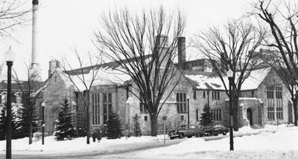
Mayo Mitchell Student Center was originally the Rochester Public Library. The building was designed by Harold Crawford and was completed in 1938.
History Center of Olmsted County

Dear Answer Man: Now that I go past it every day on my way to work, I’ve decided that Mayo Clinic’s Mitchell Student Center is the most attractive building in town. A co-worker mentioned that it used to be the public library, so can you fill us in on the history of this beautiful building? — Downtown Worker
You’re right, the Mitchell Student Center was at one time the Rochester Public Library. In fact, Answer Man has often told of escaping to the library on hot or rainy school vacation days.The building was designed by Harold Crawford, the architect of so many fine homes and structures in the city, and was completed in 1938. The Depression-era Public Works Administration paid for nearly half of the construction cost of $178,000.
The library was located in the building until 1972, when it moved to the former J.C. Penney store at 11 First St. SE. That was supposed to be temporary, but it took 20 years for the library to get its new home in its current location at Second Street and Civic Center Drive Southeast. Meanwhile, Mayo Clinic took over ownership of the building, and it became the Mitchell Student Center — think of it as a student union/study hall for Mayo’s medical school students.
By the way, fellow architecture nuts recognize that Crawford designed the building in a Tudor-Gothic style so often seen on college campuses. The result is a building that perfectly complements the more modern Mayo buildings nearby. Long may it stand.

