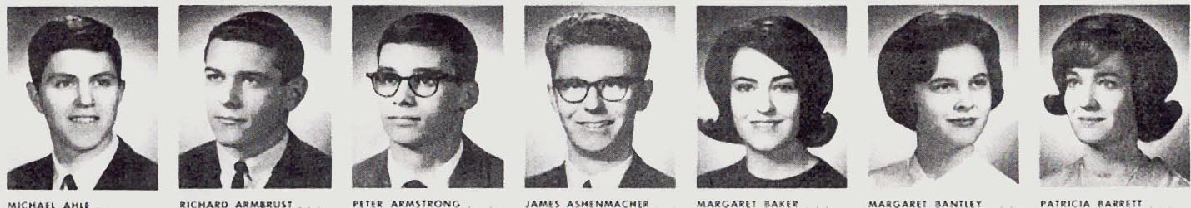
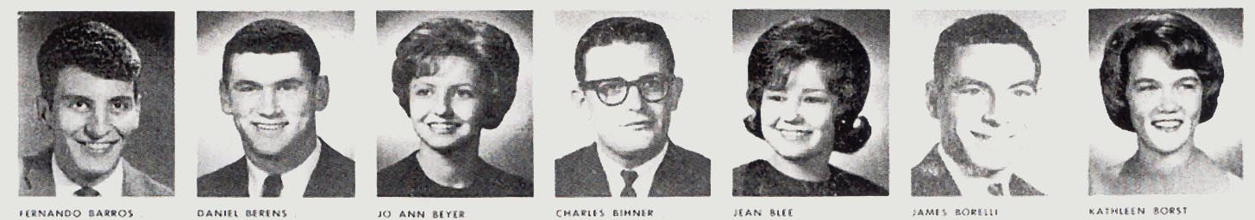
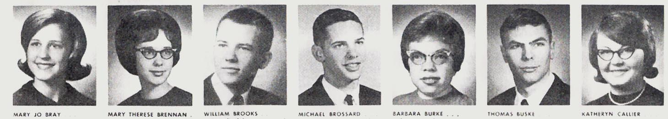
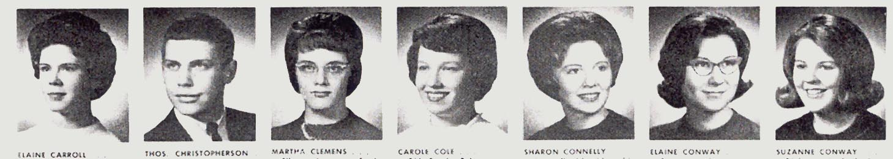
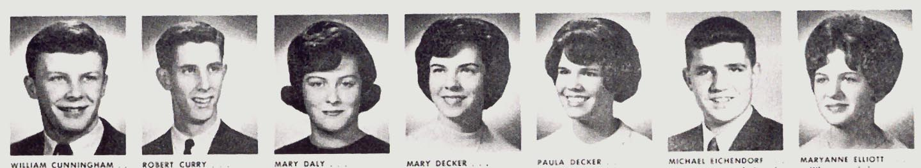
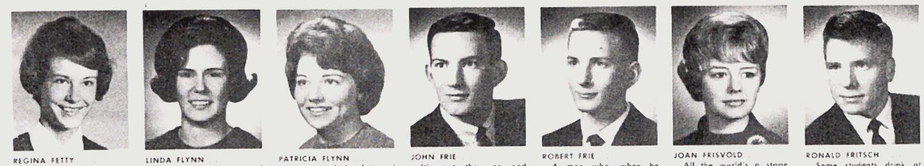
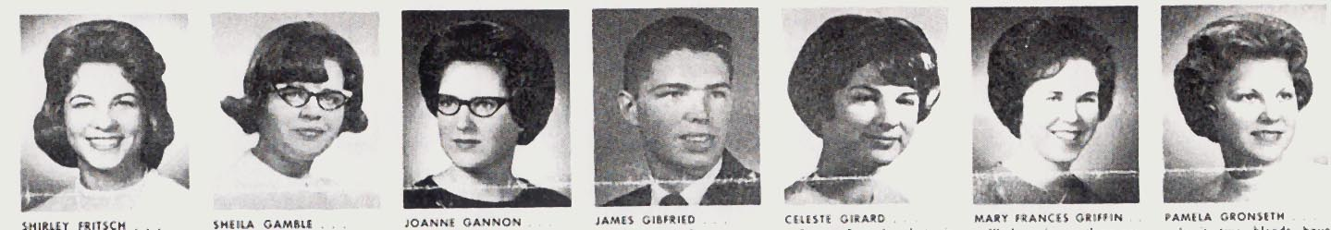
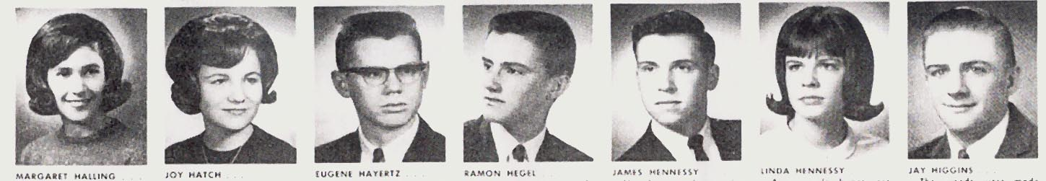
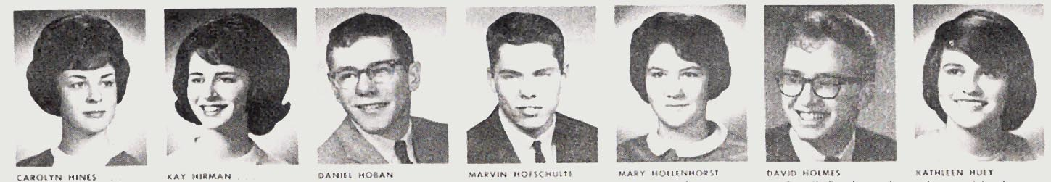
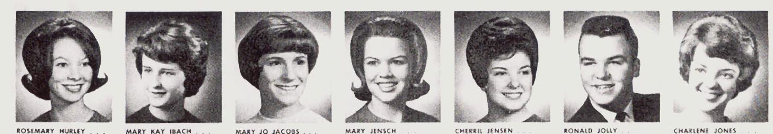
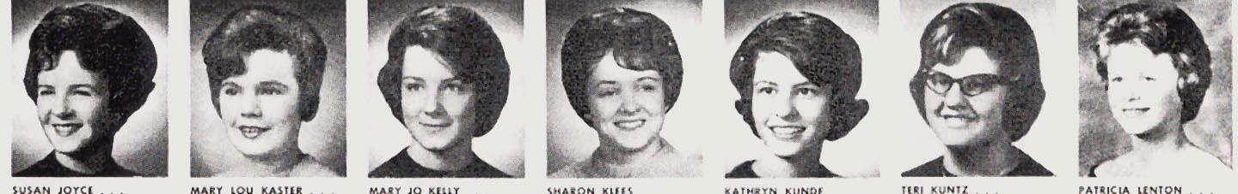
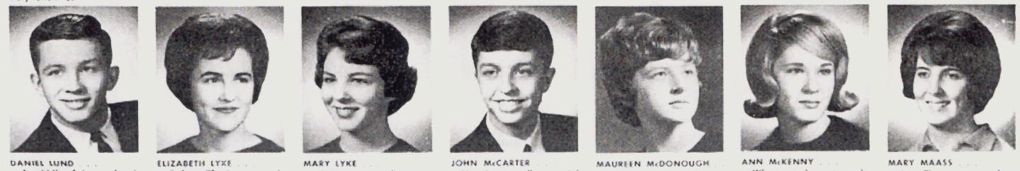
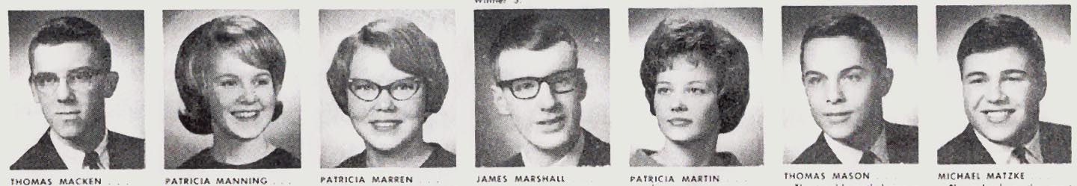
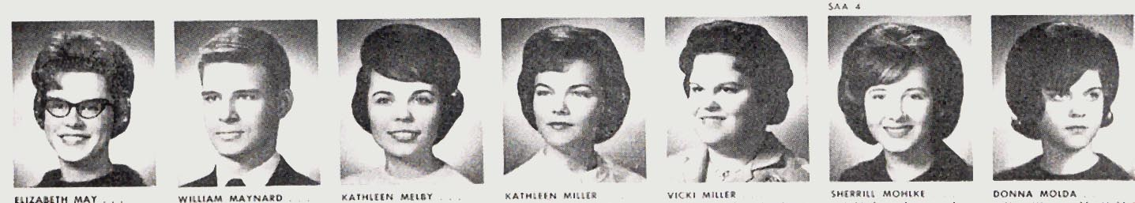
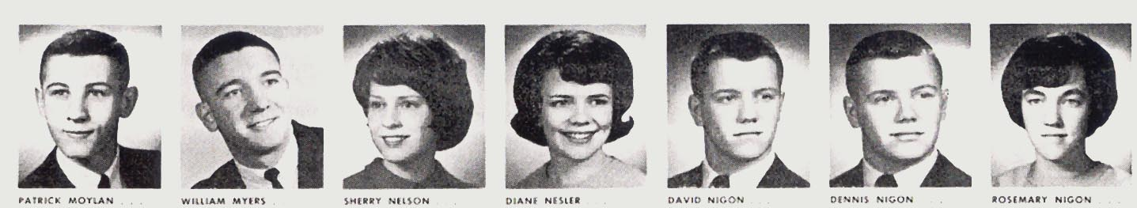
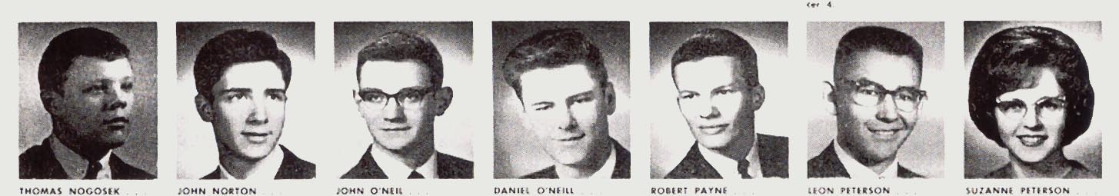
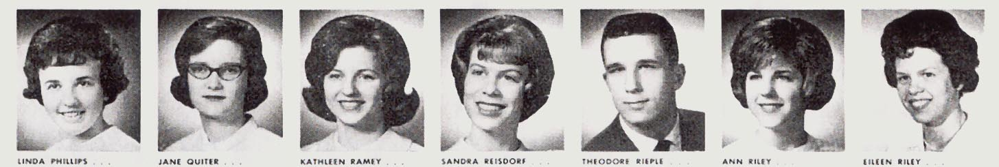
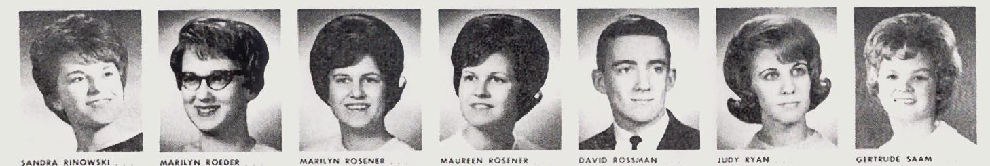
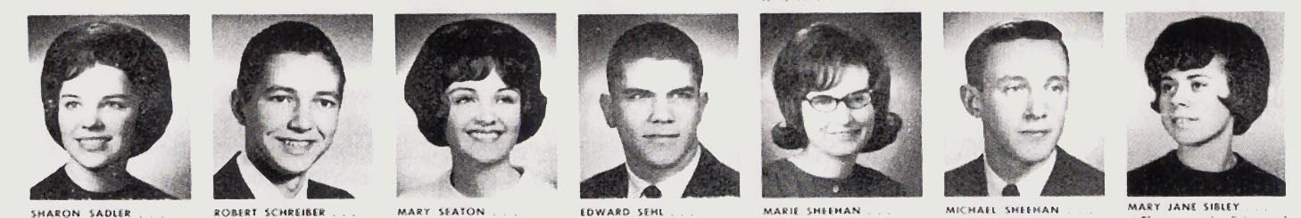
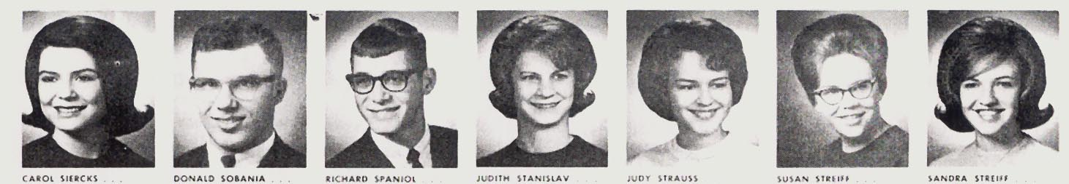
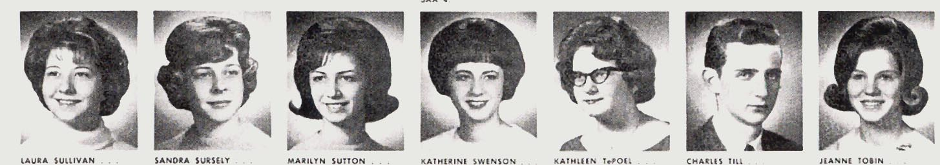
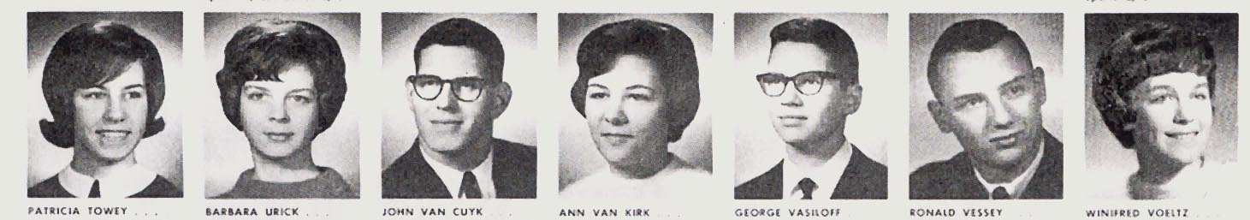
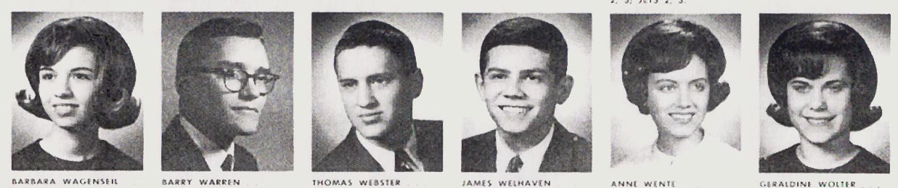

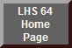
Not pictured: Vicky Amaris, Don Bisagna, Nick Carter, Jon Hrabe, Barb Pull, Lynn Rausch, Dave Smith, Paul Yochum, Anita Wolpers

