Deceased Classmates
& Others Close to Us

Armbrust, Dick  1/25/2006 Brain Tumor  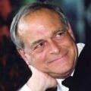 | Age 59, of Edina, died peacefully at home surrounded by family January 25, 2006. Preceded in death by parents, Walter and Virginia. Survived by loving wife of 36 years, Julie; children, Amy (Andrew) Teitscheid, Niki, and Peter; siblings, John, Ginny (Steve Yerkes), Mark (Jane), Kurt (Marie), Beth (Brian) Haman and Chris (Jodi); many nieces, nephews and loving friends, especially Barb and Larry LaLonde.  Graduate of Lourdes HS in Rochester & Hamline University of St. Paul where he was a standout football player. Family was the most important part of his life. He taught us the perfect mix of laughter, hard work, and optimism. If not attending one of the kids' sporting events, Dick could be found in the field pursuing pheasants behind a trusty Lab or spending laughter-filled weekends with family and close friends at the cabin in WI.  Dick honed his business skills with several companies before establishing Armbrust Sales & Marketing at age 30. His quick wit and sense of humor coupled with his unparalleled knowledge of the juvenile industry made him a beloved rep for Target Corp. Dick was blessed to love what he did for a living. He found great joy in working with vendors and his friends at Dept. 30.  His family would like to thank Dr. Eric Weinshel, Dr. Steven Haines, Dr. Ron DeCesare, Dr. Richard Stafford, Fairview Hospice and all of their staff.
Arndt, Carole Cole  2/27/2019 Cancer  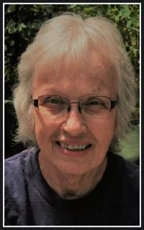 | Carole Arndt, 72, of Rochester, MN passed away Wednesday, February 27, 2019, in Davenport, IA. Carole was born September 5, 1946 in Northfield, MN to Floyd and Bert Cole. She lived there until she moved to Rochester in 1961. Carole graduated from Lourdes High School in 1964. She worked as a pediatric nurse for St. Mary's Hospital and the Mayo Clinic for over 35 years until she retired in 2014. Survivors include her two daughters, Kris Arndt of Des Moines, IA and Lynne (Hank) DeHaan of DeWitt, IA. She has two granddaughters, Anastasia and Nicole; three grandsons, William, Lukas and Henry; and one great-granddaughter, Lariyah. Carole was a sports fanatic. She loved watching Vikings football in the fall, college basketball in the winter, and Twins baseball in the summer. She also enjoyed playing cards and spending time with friends and family. The funeral Mass for Carole Arndt will be at Pax Christi Catholic Church in Rochester with Rev. Thế Hoàng officiating. Burial will be in Grandview Memorial Gardens in Rochester.
Battey, Linda Flynn  9/29/2017 Cancer  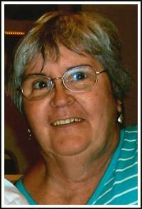 | Linda M. (Flynn) Battey, 71, of Rochester, passed away peacefully Friday, Sept. 29, at Cottagewood in Rochester. She was born to Stephen and Lucille (Nigon) Flynn in Rochester on Dec. 27, 1945. On Jan. 17, 1981, she married Richard in Stewartville. Linda worked in the histories department, X-ray records and keys management for the Mayo Clinic and retired in 2000, after 25 years. She loved crafts and making quilts. She enjoyed traveling to Seattle, Florida and the Twin Cities to see her children and grandchildren, who she gratefully spoiled. Linda had lived in sobriety for over 37 years and was an active participant in Alcoholics Anonymous. Linda was preceded in death by her parents, Stephen and Lucille Flynn. She will be remembered by her loving husband of 36 years, Richard; son, Gary (Linda) Haas; daughter, Sonja Haas (JaJa Drew); stepdaughters, Nora Candela, Dorie King, and Debra Iglesias; grandchildren, Rachel, Joey, Xavier, Nadia, Mark (Misty) Huffman, Christina (Nathan) Pineault, Heather and Santana; great-grandchildren, JoJo, Noah, Caleb and Luke; and siblings, Patty Kasey, Jim (Marge) Flynn, Bridget (Donny) Skrukrud and Vince (Sharon) Flynn.
Berens, Marilyn Rosener  5/1/2017 Lung Cancer  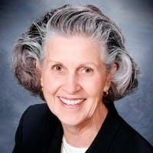 | Berens, Marilyn Susan age 71 of Plymouth, MN, formerly of Rochester, died Monday, May 1, 2017 at the JA Wedum Residential Hospice with her family by her side following a short illness with lung cancer. May 1 was May Day and Law Day. Marilyn was born February 25, 1946 in St. Paul, MN and was later adopted by Mr. and Mrs. Theodore and Mary Rosener along with her twin sister Maureen. She grew up in Rochester, attended St. Francis of Assisi Catholic grade school and graduated from Lourdes High school in 1964. Marilyn was married on June 26, 1970 to Daniel J. Berens at St. Luke's Catholic Church in St. Paul. They lived in St. Paul before moving to Glencoe, MN, where they raised their sons Michael and George. They divorced and Marilyn moved to Plymouth where she enjoyed her remaining years. Marilyn was employed by Kyle Hunt & Partners Inc. in Deephaven, MN, as the "Licensed Assistant to the President." She was involved in all aspects of the real estate business. Marilyn is survived by her sons, Attorney and Veteran Michael (Whitney) Berens of Port Orchard, WA, and Attorney George (Michelle) Berens of Maple Grove, MN. Both sons served in the Peace Corps. Her grandchildren, twin girls Allie and Brooke (9) & George (11) - Michael and Whitney's children. Her twin sister Maureen A. Stevens, her brother Richard (Joanne) Rosener, three nieces, Jennifer (Sean) Brakeman and Sara Stevens of Chicago, IL, and Estee M. Rosener of Phoenix, AZ. She was preceded in death by her parents Theodore (Ted) and Mary (Hofshulte) Rosener. Marilyn will be missed dearly by all. Marilyn exhibited an abundance of energy in everything she did.
Bihner, Chuck / Charlie  5/2/2002 Heart Attack  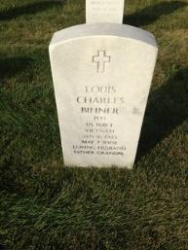 | Charles Bihner, 57, of Siren, Wis., formerly of Rochester, died Thursday (May 2, 2002) at the Amery, Wis., Medical Center. He was born Jan. 16, 1945, in Richland, Wash. He lived in Rochester for a number of years and was employed by Erdman Supermarkets. Survivors include his wife, Carol; two sons, Greg (Jeni) of Oakdale, Minn., and Jeff (Katie) of Hudson, Wis.; two grandchildren; and a sister, Joan (Jerry) Knutson of Homosassa, FL.
Blondell, Ricky  7/7/1953 Hit by a car | 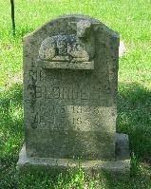
Boudreau, Kathy Swenson  5/10/2017 Cancer  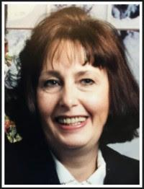 | Katherine Boudreau, 71, of Rochester, passed away at her home in the arms of her children on May 10, 2017. Katherine Swenson was born July 21, 1945, in Bemidji, Minn., to Leonard and Virginia Swenson. She grew up in Rochester and was a graduate of Lourdes High School. On April 30, 1966, Katherine married Pierre Boudreau at St. Johns Church in Rochester. They resided at their lake home in Oronoco where they raised their two children, Tammy and Bradley. In 1990, Pierre and Katherine moved to her beloved home in Rochester where she resided until her passing. She received her nursing assistant degree from Rochester Community College in 1990. She worked in home health care for many years and then went on to employment at Mayo Clinic, where she retired in 2007 after 15 years of service. Katherine is survived by her daughter, Tammy Childs, of Rochester; her son, Bradley Boudreau, of Grand Ronde, Ore.; her grandson, Tyler Childs; two sisters-in-law, Deneige Boudreau and Arlette Padden; and the Berg family.
Brossard, Mary Decker  11/21/1981 Cancer  Brossard, Mike  8/6/2015 Huntington’s Disease  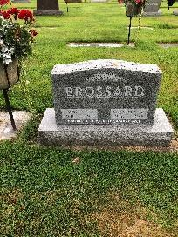 | Mr. Brossard, 69, of Rochester, passed away peacefully surrounded by family at his home on Thursday, Aug. 6, 2015, due to complications of a long-term illness.  Mike was born on March 1, 1946, in Rochester to Louis and Helen (Bucher) Brossard. He grew up in Rochester and graduated from Lourdes High School and Rochester Community College. He was honorably discharged from the Army Reserve on April 30, 1972. Mike retired from IBM after 30 years in 1997. On Oct. 21, 1967, he married Mary L. Decker in Rochester. She passed away on Nov. 24, 1981. On Oct. 27, 1984, he married Sandy Trcka in Montgomery.  Michael is survived by his wife, Sandy; daughter, Shelley (Troy) Bjerke of Rochester; sons, Kerry (Jody) Brossard of Byron and Kyle Brossard of Rochester; brothers, Paul of Rochester and Gregory of Costa Rica; grandchildren, Breanna Bjerke of Rochester, Calvin Bjerke of Rochester, Tyler Brossard of Byron and Cody Brossard of Mankato. He was preceded in death by his first wife, Mary, mother, Helen, father, Louis, brother, Steve, and son, Cory. Burial will be at Calvary Cemetery.
Burke, Barbie  9/5/1971 Pneumonia | 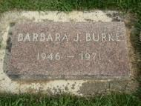
Carroll, Therese Brennan  12/10/2022 Cancer  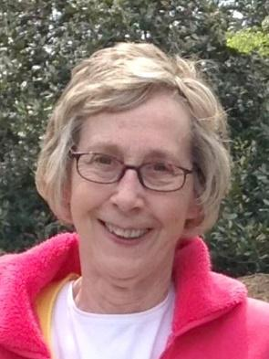 | Mary “Therese” Carroll, 76, of Rochester, MN passed away on December 10, 2022, at Season’s Hospice House. Mary Therese Brennan was born in Rochester on February 9, 1946, to Martin and Dorothy (Meyer) Brennan. She graduated from Lourdes High School in 1964 and attended Dental Assistant school soon thereafter. In April of 1967, she married Howard Carroll and the couple raised their three children in Rochester. She worked as a Dental Assistant and home daycare provider before being employed by IBM, Celestica, and Olmsted Medical Center. Volunteering at the local elementary school and for Olmsted Medical Center during retirement brought her great joy, and she often said her grandchildren were the love of her life! Therese is survived by her daughter Amy Carroll of Minneapolis, son Chris Carroll of Delano, MN and grandchildren Bryana, Jack, Hailey, Owen and Catalina. She is preceded in death by her parents, brother Joseph Brennan, and son Casey Carroll.
Conner, Jane Quiter  2/24/2015 Melanoma  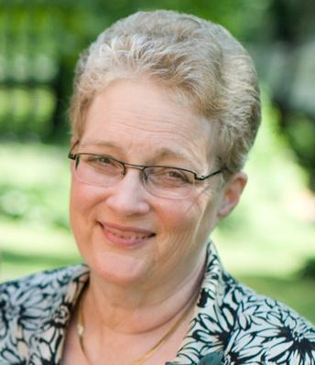 | Jane E. Connor, age 68, passed away Tuesday at St. Therese Hospice at St. Odilia in Shoreview after a three-year battle with melanoma.  Jane was born Sept. 25, 1946, in Rochester to Joseph & Helen "Pat" (O'Neil) Quiter. She married Jerry Connor on Oct. 11, 1969, at St. Francis Catholic Church in Rochester. She lived in the Sauk Rapids/St. Cloud area all her married life. Jane was a bookkeeper for Coborn's for 30 years, retiring in 2015. She was a member of Sacred Heart Catholic Church where she was a member of the Christian Mothers, a Eucharistic Minister, and volunteered at the bazaar and fish fry. She also volunteered for the local Girl Scouts and Cub Scouts. Jane enjoyed reading, traveling with family and friends, logic puzzles, scrabble, the Food Network, margaritas, and exposing her grandchildren and herself to new adventures. She was kind, thoughtful, forgiving, adventurous, and determined. Faith was very important to her. In her true charitable form, Jane donated her body to science.  Survivors include her husband, Jerry of Sauk Rapids; children, Jennifer (Kevin Doll) Connor of St. Paul, Jill (Brian) Hedlund of St. Paul, Joel of St. Louis Park , and Jacquelyn (Marc) Bacigalupi of Baxter; mother, Pat Quiter of Rochester; brothers, John (Elaine) Quiter of Berkley, CA and Jim (Karen) Quiter of Walnut Creek, CA; grandchildren, Connor, Joseph, Vivian and Andrew; and many nieces and nephews. Jane was preceded in death by her father, Joseph.
Cunningham, Bill  10/16/2024  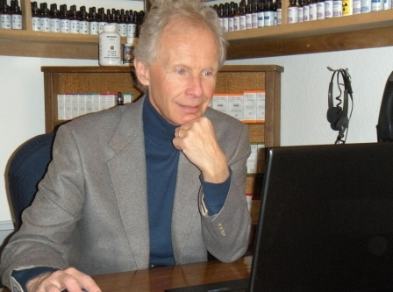 | Bill Cunningham was born 7 November 1946 in Rochester, Minnesota, to Jerry and Gert Cunningham. He graduated from Lourdes High School in 1964, and from the University of Minnesota in 1968. Married with a young family, he moved to Boulder, Colorado in 1980, to pursue his dream of working in the field of nutrition to improve health. His passion led him to become a certified homeopathic doctor, and to create White Dove Healing Arts, a Quantum Biofeedback and Homeopathic practice with his wife Patricia. He was a teacher and mentor to hundreds of practitioners in the field. Bill lectured and gave seminars in the United States and abroad. His contribution in the field of Homeopathy and Quantum Biofeedback is considered unprecedented. He is survived by his wife Patricia, his three sons Joseph, Jacob and Ryan and their families, five grandchildren, and their grandmother Julianna. His brother Pat and sister Mary also survive him, as do his three stepsons, a stepdaughter and their families. He was preceded in death by his parents, sister Peggy, and daughter Maia. Bill’s legacy of excellence, his teachings, unwavering love and commitment to his family, and White Dove Healing Arts will inspire everyone who knew him. He will be deeply missed and forever remembered in the hearts of those he touched. A private celebration of life will be held on 30 November 2024 in Erie, Colorado.
Dernek, Father Dan  6/5/2007  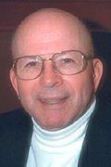 | Rev. Dernek, 71, a longtime Catholic priest in the Diocese of Winona, died Tuesday (June 5, 2007) at his home in Winona.  Born Feb. 6, 1936, in Winona, he attended St. John's school and graduated from Cotter High School in 1953 with the school's first co-educational class. After a few years, he entered I.H.M. Seminary and was ordained a Catholic priest on May 31, 1962. During his years as an active priest, he taught at Lourdes High School in Rochester; visited the sick at Rochester Methodist Hospital; served many parishes ranging from Winona to St. Peter, Minn.; worked with college students as chaplain of the Newman Center; and ministered to patients as chaplain at mental health institutions such as Rochester State Hospital and St. Peter Regional Treatment Center for 23 years.  Survivors include a sister, Gerri McElmury of White Bear Lake, Minn., and a brother, the Rev. Richard J. of Blooming Prairie.
Eggleston, Ann Van Kirk  9/14/2020 Blood cancer  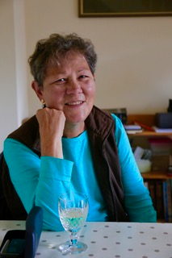 | Ann Marie Eggleston passed away August 22nd at First Health Hospice and Palliative Care in Pinehurst, NC due to Myelodysplastic Syndrome (MDS); a blood cancer.  Ann has been through a lot in the last 20 years since being diagnosed in 2003 with Inclusion Body Myositis (a debilitating muscle disease) and most recently in June 2019 with Myelodysplastic Syndrome (MDS); “preleukemia. After two chemo treatments in June she stopped treatments and never looked back. She was able to spend quality time for over a year with family and friends; even over the 4th of July this year, swimming with the grandchildren, playing cards and visiting with neighbors and family. She felt it was a good choice for her, right up to the end.  Her husband, sons, and a sister were able to be with her at home briefly and for the two days in hospice before she passed peacefully.  Ann was born in Rochester, Minnesota in October 9, 1946 to William and Mary Ellen (Rousseau) Van Kirk the eldest of 4 siblings that would join the family following Ann’s’ birth; Kathy (Hudson), Mary Beth (Nelson), Pat (Tupper) and Jeanie (Savage).  She was married October 1, 1966 in Rochester Minnesota to Rod Eggleston, at Saint Francis Catholic church. Ann was a telephone operator for AT&T for over 20 years; putting Rod through Architectural school, raising 3 boys, Mark James, Matthew Kristian (Matt) and Joshua (Josh) Peter.  Following Rods graduation in 1975, the family began an around the world adventure, from Fargo, N.D. and back; starting in Chicago in 1985, Memphis, Washington D.C., and then internationally; to Taiwan, Malaysia, the United Arab Emirates and back to Chicago; over 23 moves she used to tell friends laughingly; leaving behind children along the way; Matt in Memphis, TN, Mark in the Navy and Josh in New York.  She adjusted well to her new environments and made a home in their apartment in Taipei; had wonderful groups of friends she played bridge with, traveled Asia with and socialized with at the Taipei American club; their home away from home. She always felt special that she was allowed the time to have traveled to wonderful places and meet new friends along the way; before she was diagnosed with IBM, and began to lose her mobility. She was blessed, knew it and was thankful for every day.  Her 4 grandchildren loved their Nana and she them; to the degree that each of them communicated in their own way with her, regularly calling her, sending art work, face timing her or e-mailing her and always telling her how much they loved her and looked forward to seeing her and playing cards and swimming in the lake.  She savored her last month’s sitting on the deck of their lake house with Rod and Bella her Bichon lap dog and friend; for a cocktail and music as well as sundown boat rides when she often napped in the cool breezes listening to Patsy Cline, Willie Nelson and Merle……  Ann is survived by 4 sisters, Cathy Hudson (Centralia WA), Mary Beth Nelson (Rochester MN), Pat Tupper (Rocheter, MN) and Jeannie Savage (Wabasha, MN). Three sons, Mark James (Williamsburg, VA), Matthew Kristian (Nashville, TN), and Joshua Peter; Durham NC. 4 Grandchildren; William Eggleston (18) (Memphis TN, MasonEggleston (16) and Henry (3) both Williamsburg VA, Parker Eggleston (8), Durham NC.  She was preceded in death by her Parents William C. Vankirk, and Mary Ellen (Rousseau), her grandparents; William A. Vankirk, and Maude (McCoy), and Emil and Marie Rousseau.  Always a courageous person in her battle for 20 years with IBM and ultimately her cancer; She shared her love and bright light to friends and family as only she could; she will be missed by all but her smile will be with us forever and her spirit and energy will fill the universe she now occupies.  There will be no funeral or services. There will be a Celebration of Life at Rod and Ann’s home in Seven Lakes West, for friends sometime in the future; with a family Celebration of Life in Rochester, Minnesota, to be determined; after the Covid issue is resolved. Please send no flowers to the house.  Any Memorials may be given to The Myositis Association; at Myositis.org. This is a disease that has too little funding as it is a rare and evasive disease. More needs to be accomplished.
Eichendorf, Mike  12/16/25  Poor health, several issues  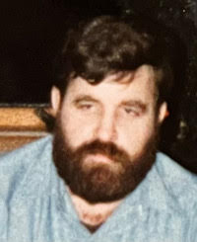 | Michael L. Eichendorf passed on into eternal life on December 16, 2025 at Methodist Hospital after an extended battle with medical issues. Mike was born at St. Mary’s Hospital on October 28, 1946. He was 79. He attended St. John’s Catholic Grade School and graduated from Lourdes High School in 1964. He also attended Rochester Jr. College and then enlisted in the Navy for four years. He was stationed in Pensacola, Florida where he was an Aircraft Carrier Mechanic and earned the rank of E5 Second Class AME. He worked on the Blue Angels.  After his honorable discharge, he got a job at Assisi Heights as a boiler engineer, serving the needs of the Franciscan sisters for 53 years. Mike is survived by his sister Judy (Eichendorf) Kidder and her husband Bill. He is also survived by loving nieces and nephews, friends and relatives. He was preceded in death by his mom and dad, Irene and Leonard Eichendorf and his sister and brother-in-law.
Eiden, Gene  12/24/2023  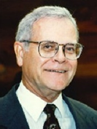  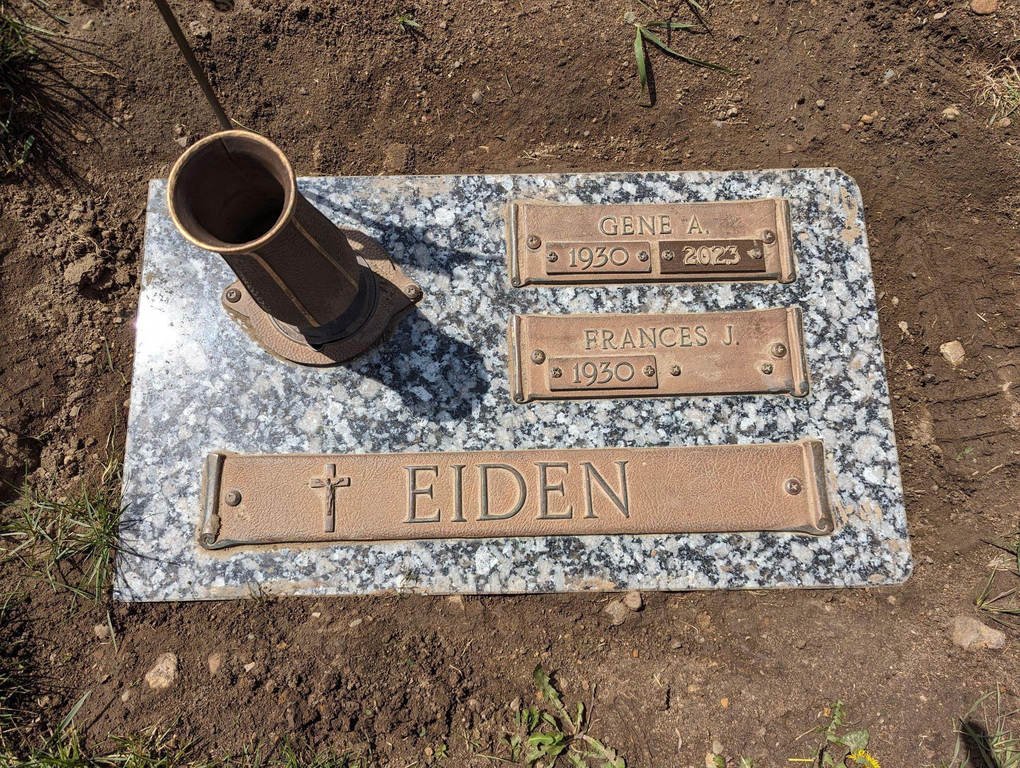 | Gene A. Eiden, age 93, longtime Rochester resident, musician, and former Lourdes High School music educator died Sunday, December 24, 2023, surrounded by family, at Mayo Clinic Hospital, St. Mary's Campus.  Gene Albert Eiden was born July 6, 1930 in Holdingford, Minnesota to Albert and Helen (Mulvey) Eiden. He attended Holdingford and Sauk Center elementary schools and graduated from Melrose High School. He then received his degree in music education from St. John’s University, Collegeville, Minnesota.  Gene married Frances Juliana Rassier on June 27, 1953, at St. Columban Church in Littlefork, Minnesota. That August he began his service in the Army which he completed in 1955 at Fort Leonard Wood, MO playing in the 6th Armored Division Band.  Gene started his teaching career in Claremont, Minnesota. He retired from teaching in 1993 after 38 years at Lourdes High School in Rochester, where he directed choirs; pit orchestras for musicals; and concert, marching, and stage bands, as well as pep bands for multiple sporting events. He was always willing to provide music for community events whenever called. Occasions included presidential visits, parades for summer festivals, and mayoral requests for city functions. He also directed the Mayo Clinic Notochords stage band and adult choirs for St. John’s, St. Pius X, and Pax Christi Catholic Churches. As a musician, he played various instruments, primarily trumpet. He played in the Rochester Symphony Orchestra, Rochester City Band, Civic Theatre pit orchestras, Brass Quintet, religious services, and multiple old-time bands. He was dedicated to providing Taps for every military funeral in the Rochester area (doing more than 150 the year he turned 90) until a week before he died.  Gene was the oldest of ten children; Donna Mae (Victor) Fink, Leslie (Arlene) Eiden, Darrell (Irene) Eiden, Arliss (Robert) Liebel, David Eiden, Neil (Janice) Eiden, Merle Eiden, Thomas (Teresa) Eiden, and Gerald (Irene) Eiden. He was preceded in death by Donna Mae, David, Merle and two sons-in-law, Keith Kangas and Loren Stortz.  In addition to Frances, his wife of 70 years, Gene is survived by his son Wayne (Kathleen) Eiden, Kay Kangas, and Carol Stortz. He felt blessed by his ten grandchildren and nine great grandchildren.  Gene received numerous honors including; 2014 Minnesota Music Hall of Fame, City of Rochester Mayoral Medal of Honor, two City of Rochester Gene Eiden Day Proclamations, Minnesota Teacher of the Year Finalist, Rochester Quarterbacks Club Sports Hall of Fame, Lourdes Foundation Presidents Award, and the Diocese of Winona Bishops Medal.  The family would like to thank the first responders and Mayo Clinic staff participating in his emergency and in-patient care. Gene was most grateful to all, including Dr. Tom Poterucha.  The funeral mass will be held at 11:00 a.m. Saturday, January 6, 2024 at Pax Christi Catholic Church in Rochester, MN with Rev. John Sauer officiating. Visitation will be held from 4:00 p.m. to 7:00 p.m. on Friday, January 5, 2024, in the River Park Chapel at Macken Funeral Home and one hour prior to the service at Pax Christi Catholic Church on Saturday. Burial will be at Calvary Cemetery with military honors by the American Legion Post 92.  Memorials are preferred to the Lourdes High School Music Department, Gene Eiden Scholarship Fund, or Pax Christi Catholic Church.
Faber, Dennis  1961 Intestinal Blockage | 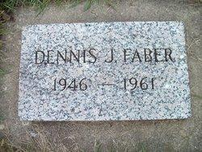
Frank, Barbara Urick
9/2015
Garrison, Sandy Streiff  5/31/2025 Poor health overall  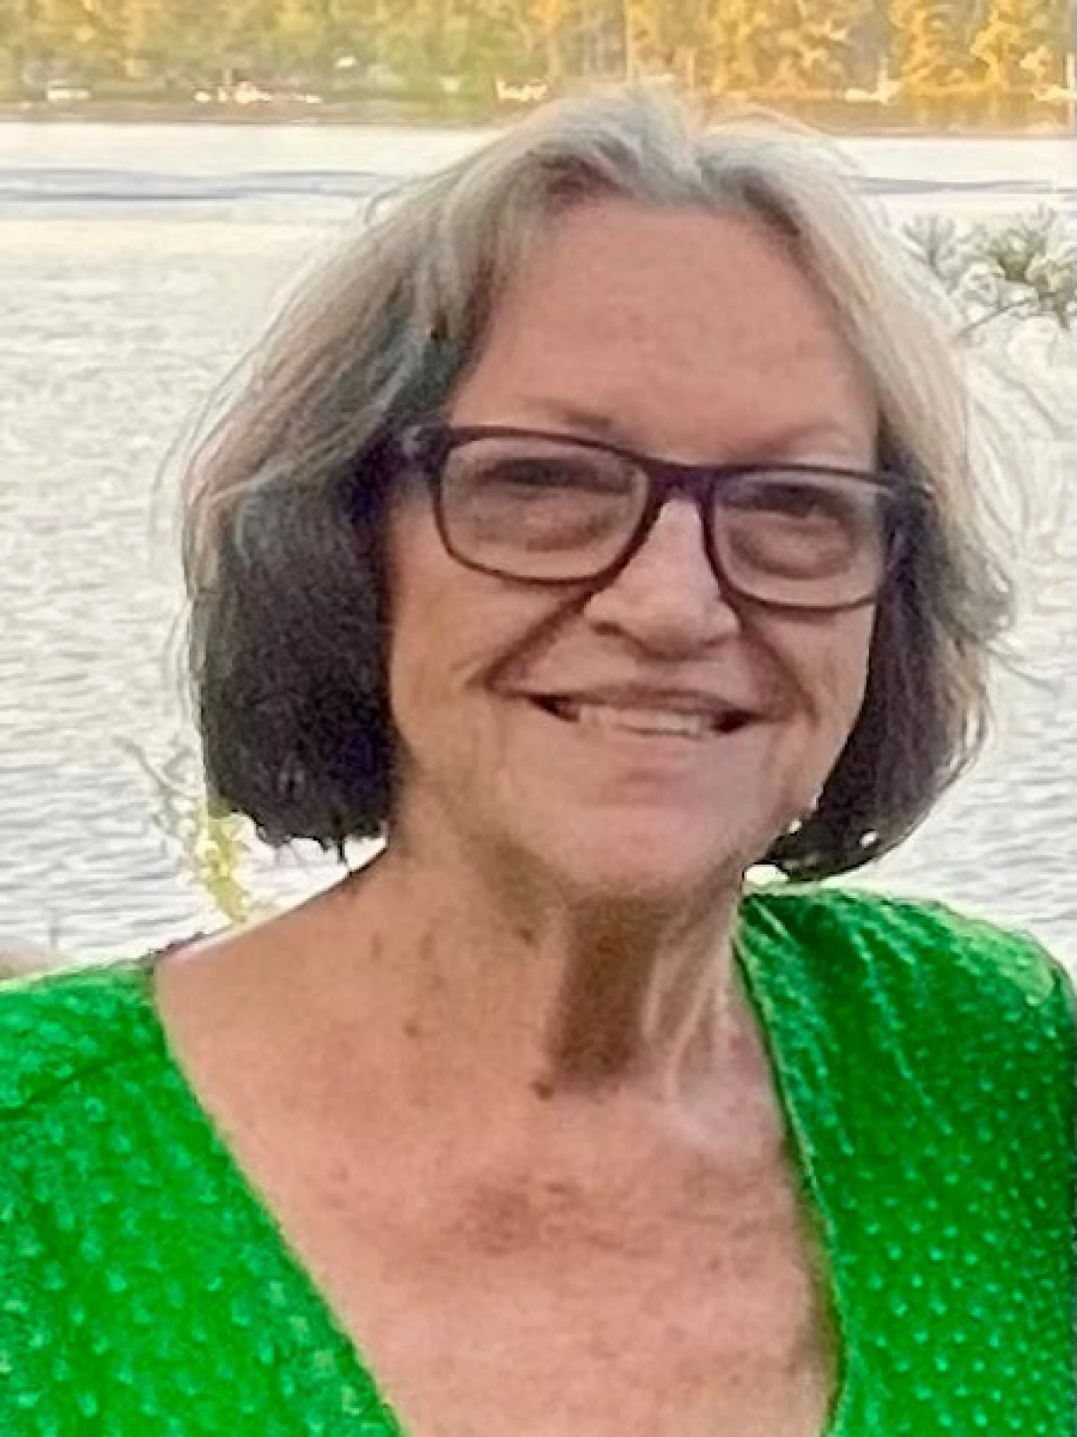 | Ms. Sandra Marie “Sandy” Garrison, age 78, passed away peacefully on May 31, 2025, at her home in Rochester, Minnesota, the city where she was born on February 16, 1947, and where she spent much of her life. On August 3, 1974, Sandra married George Garrison and together they had two children, Aaron and Laurel. Sandra and George spent lots of time traveling internationally throughout the years, even living in Iran and Saudi Arabia together, before separating several years later.  Sandra built a meaningful career at Mayo Clinic in Rochester, Minnesota, where she worked as a Unit Secretary. After many years of service, she retired from Mayo Clinic, leaving behind many good friends, but cherishing the memories made for years to come.  Outside of work, Sandra embraced life with humor and creativity. Known for her quick wit and sharp sense of humor, she could just as easily take a joke as deliver one with perfect timing.  Sandra had a deep appreciation for beauty and craftsmanship. She enjoyed spending long hours creating artwork out of stained glass. Her love for gardening and planting flowers brought color and joy to her surroundings. A passionate cook and family-proclaimed "foody," Sandra delighted in exploring new recipes and flavors of various cultures.  In recent years, she found comfort in quieter pleasures. She enjoyed relaxing in her recliner with the television tuned to QVC, often ordering next years’ Christmas and birthday gifts for her loved ones...sometimes ordering more gifts than she knew what to do with.  Sandra is survived by her son, Aaron Garrison and fiancée, Angela Best; her daughter, Laural Garrison; sisters Marcia Bussman and Rita (Bill) Bussman, brother Mark (Kris) Streiff; grandchildren Rubie (Carter) Benike, Violet Garrison, and Austin Best, along with other family including nieces and nephews who were very special to her. Sandra is preceded in death by her parents, Vyford and Evelyn Streiff, and her grandson, Jacob Bale.  Sandra’s warmth extended deeply into the lives of those who loved her. Though not all family members are named here, it brings peace to know that she is now reunited with her beloved grandson Jacob in heaven, a reunion that offers comfort amid sorrow.  A short, but intimate service took place at Macken Funeral Home in Rochester, MN, with some of Sandra's closest family members present. At Sandra's request, she is a donor to the Mayo Clinic Anatomical Bequest Program.
Grassle, Elaine Carroll
9/6/2010 Breast or Lung Cancer
Higgins, Jay  1/5/2018 Brain Cancer  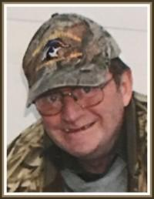 | Jay Michael Higgins, age 71, passed away Friday, January 5, 2018, at Mayo Clinic Saint Mary’s campus. Jay was born May 20, 1946, to Mike and Lois Higgins at Saint Mary’s hospital in Rochester, the eldest of their five sons. Jay graduated from Lourdes High School in Rochester in 1964 where he was active in the football program. Following graduation Jay attended Rochester Junior College. On August 31,1966 Jay married Peggy Brown prior to enlisting in the military. During his service Jay was awarded the Bronze Star Medal. Upon discharge, Jay and Peggy moved to Morris, Illinois where they resided for 18 months before returning to Rochester. Jay spent the majority of his life working in the telecommunications field first with Northwestern Bell, then transitioning to AT&T where he retired after 26 years. He returned to the workforce after retirement working for a private client, then joined Mayo Clinic as a contracted Telecommunications specialist, where he retired from after five years. Jay had many different interests. He was involved with multiple different wildlife conservation efforts on the local level including 25+ years in the local Ducks Unlimited chapter. Jay was an active member of the Rochester Youth Hockey League as a parent, coach, and head referee for the league. He participated in adoration at Resurrection Catholic Church for more than 16 years. He enjoyed hunting and fishing with friends and family, especially those adventures that took him to numerous states and Canada. NASCAR and Friday morning coffee club with friends were also some of his favorite pastimes. Jay is survived by his wife, Peggy, and their children: Jennie Stankey of Pine Island, Brian (Carrie) Higgins of Shallotte, NC, and Chris Higgins of Rochester. 10 grandchildren: Ashley Stankey, Will Stankey, Marybeth (Nick) Lanier, Heather Higgins, Michael Higgins, Ben Higgins, Kristina Higgins, Andrew Higgins, Zoe Stevens, Violet Stevens and two great-grandchildren Ava and Wally Lanier. Four brothers: Tim (Judy) Higgins of Sun City, AZ, Jeff (Diane) Higgins of West St. Paul, MN, Matt (Mary Ann) Higgins of Geneva, MN, and Kevin (Nita) Higgins of Rochester, as well as many nieces, nephews and extended family and friends. He was preceded in death by his parents. The burial is at Veterans Memorial Cemetery in Preston MN.
Huey, Rick  1961 Leukemia | 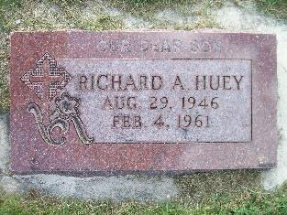
Julitta, Sister (Jutta)  2024 / 97 yrs. old | • Sister Jutta Gleichaufwas born in Ironton, Ohio, and entered the Sisters of Saint Francis Congregation from St. Joseph Parish in Ironton, professing first vows in 1954. She received a bachelor's degree in economics from the College of Saint Teresa, and a master's in business administration from Notre Dame. Sister Jutta spent her career in business education and office administration in Albert Lea, Rochester, Rollingstone and Waseca, as well as Norfolk, Neb., and Portsmouth, Ohio. She also spent 31 years as office manager for Lourdes High School in Rochester.
Lang, Sue Joyce  7/2/2022  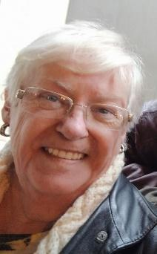 | Mary Susan (Sue) Lang, age 75, passed away peacefully on Saturday, July 2nd, 2022, at her home in Longview, Texas. She was born on September 5, 1946, in Rochester, Minnesota to George Leo Joyce and Helen Tuohy Joyce. She was a 1968 graduate of St Theresa’s College of Nursing. She married Robert Gerald (Jerry) Lang on June 29, 1968.She is survived by her husband of 54 years, Jerry; children, Bob Lang (Kelly); Steve Lang; and Jennifer Lang-McMillin (Brant); grandchildren, Thomas Lang; Peter Lang; Morgan McMillin; and Ian McMillin. The Lang family would like to extend our sincerest gratitude to the members of St. Matthew’s Catholic Church for their attentiveness and loving care.
Lange, Carol Siercks  3/5/2025 Parkinson’s  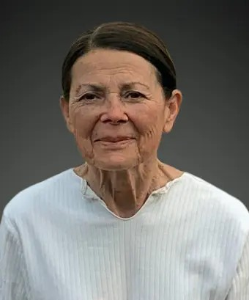 | MORTON – Carol A. Lange, 78, of Morton, passed away peacefully on Wednesday, March 5, 2025. She was born on March 28, 1946, in Wabasha, Minnesota, to James and Verniel Siercks. Carol was the most beloved wife of Kermit Lange for 58 years.  Surviving are her husband, Kermit; children, Becky (Tim) Gleason, David Lange, Tim Lange and Jason (Suzanne) Lange; her grandchildren, Brett, Clint, Kaila, Breanna, Bekah, Presley, and Henry; nine great-grandchildren; and one sister, Becky (Delbert) Moody.  Carol was preceded in death by her parents and two brothers; Chuck Siercks and Pat Siercks.  In addition to loving and caring for her family, Carol was a devout Catholic and her faith was a big part of her life. She would frequently attend daily Mass and was a longtime member of St. Mark Catholic Church in Peoria. She also volunteered her time to help the less fortunate.  Carol loved the outdoors and would spend long hours walking several miles a day and taking care of her yard. For many years, she also maintained the flowers and landscaping at St. Mark Catholic Church.  Carol’s sweet tooth was well known. Her favorite desserts are too numerous to mention here and she would offer her grandchildren ice cream before bed. She had a penchant for turning up the volume and dancing to her favorite songs. She had a lead foot and surprisingly only got one speeding ticket.  A Mass of Christian Burial will be held at St. Mark Catholic Church at 11 a.m. on Wednesday, March 12, 2025, with Fr. Robert Lampitt officiating. Visitation will be held from 5 to 7 p.m. on Tuesday, March 11, at Knapp-Johnson Funeral Home and Cremation Center in Morton. Further visitation will be held from 10 to 10:45 a.m. Wednesday, prior to the service, at the church. Burial will be at Hirstein Cemetery in Morton.  She will be deeply missed by those who knew and loved her. Memorials may be made to the Parkinson’s Foundation. Knapp-Johnson Funeral Home and Cremation Center in Morton is handling arrangements.  To leave an online condolence for the family visit www.knappjohnson.com.
Leary, Father Don  8/15/2016  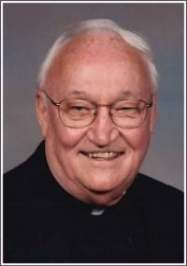 | Born on November 29, 1926, Father Leary was the third of four boys born to Ethel and George Leary of Caledonia, MN. Like his brothers, he participated in the great boxing tradition of Caledonia. He attended Loretto High School in Caledonia and went on to receive his BA degree at Loras Catholic College in Dubuque, Iowa. He attended St. Mary’s Seminary in Baltimore, Maryland and was ordained a priest on May 19, 1951. Father Leary dutifully answered the call of the Bishop of the Winona diocese by serving the parishes of St. Mary’s in Winona, Sacred Heart in Hayfield, Our Lady of Loretto in Brownsdale, Sacred Heart in Waseca, St. Patrick in LeRoy, St. Bernard in Stewartville, St. Mary in Lake City (twice), St. Casimir in Wells, St. Mary in Chatfield, St. Anthony in Altura and St. Aloysius in Elba. Father Leary was especially honored to serve as Principal at Lourdes High School in Rochester. Preceded in death by his parents, brothers Bill, Harold and Bob; sisters-in-law, Faith and Rita, nephew Tom, and his dear friend Sister Olga. Survived by sister-in-law, Susan Leary, nieces, nephews, and his loyal friend since childhood Sister Mary Esch of Assisi Heights
Lund, Danny  6/16/1993 Suicide  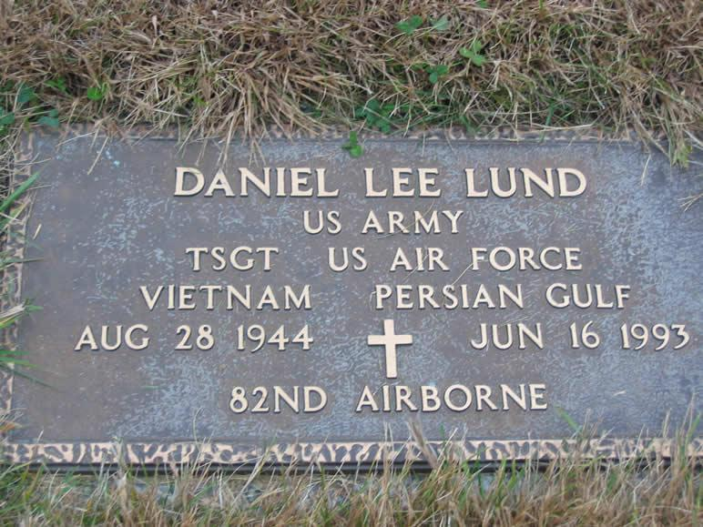 | The. funeral for Daniel Lee Lund will be 3 p.m. Saturday at First Presbyterian Church, with the Rev. W.L. Loessin officiating. Burial will be in Grandview Memorial Gardens. Mr. Lund, 48, of 422 10th Ave. N.E., a longtime Rochester resident and retired member of the Air National Guard, died Wednesday (June 16, 1993) at his home. The death has been ruled a suicide. Born Aug. 29, 1944, in Lawton, Okla., he moved to Rochester as a child, graduated from Lourdes High School in 1964 and had done course studies with the Bureau of Criminal Apprehension. He served in the Air National Guard for 29 years before retiring in April1993. During the Vietnam era, he served one tour of duty with the Army and one tour with the Air Force. He received his basic training at Fort Leonard Wood, Mo., and Fort Bliss, Texas, and in addition to Korea had been assigned duty in Minneapolis, Okinawa and Fort Benning, Ga. At the time of his death he was employed by IBM. On Sept. 6, 1969, he married Rosie Lewis in Rochester. She works at Mayo Clinic. Mr. Lund was a member of the 173rd Sky Soldier Airborne, the American Legion and VFW. He was an avid hunter. Survivors include his wife; a daughter, Terry of Rochester; his parents, Andrew and Evelyn ``Peg'' Lund of Rochester; five brothers, Christopher of Wasilla, Alaska, Mark, Kevin and Kelly, all of Rochester, and Andrew ``Joe'' of Sullivan, Mo.; and seven sisters, Linda Torgrimson, Flossie Lund, Kimberly Quinn and Ginger Hughes, all of Rochester, Fannie Connaker of New Hope, Minn., Peggy Finseth of Eyota and Heidi Fieden of Chaska, Minn. A son preceded him in death.
Marren, Patricia  10/22/2024 various ailments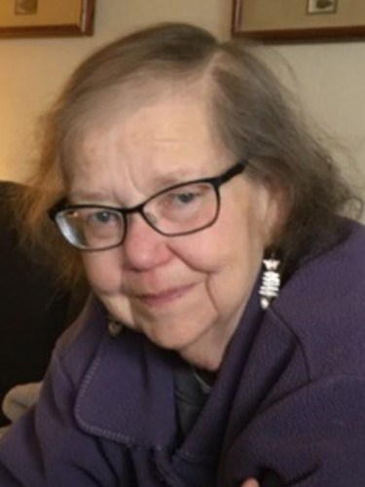 | Patz Marren  March 15, 1946 - October 22, 2024  Patz Marren, a longtime resident of Petaluma, died peacefully in Minnesota where she had gone to live with her sister. Patz was born in Minnesota and moved to California in the 1960s, settling in Petaluma over 50 years ago. Patz served as a financial aid counselor at Sonoma State for many years, was a long time member of the Petaluma 7-11 Lions Club, and was a good friend to so many people. She is remembered for her goodness and her irreverent sense of humor. Patz was preceded in death by her husband, Matt Wilson, and many beloved pet dogs. She leaves a hole in the hearts of many dear friends. There will be no service; friends request donations to the 7-11 Lions Club of Petaluma if you wish to remember her in this way
Matzke, Mike  4/19/2005 Esophageal Cancer  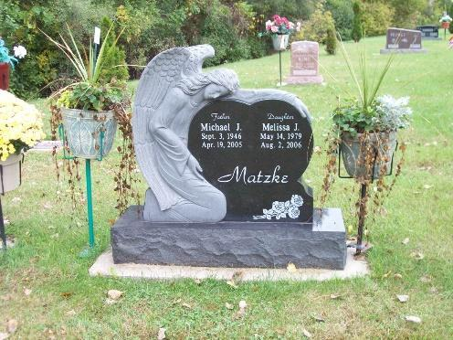 | Mr. Matzke, 58, of Rochester, died Tuesday (April 19, 2005) at his home following a brief illness. Born Sept. 3, 1946, in La Crosse, Wis., he graduated from Lourdes High School in 1964. He married Sherry Kolden in Rochester, and they later divorced. In May of 2003, he married Lyudmila Balyasna; she works for the St. Croix Shop at Hanny's Clothing. A lifelong resident of Rochester, he was trucking manager for Kuehn Motors and a member of St. John the Evangelist Catholic Church.  Survivors include his wife; a daughter, Melissa Matzke of Rochester; a son, Michael Jr. of Rochester; one grandchild; his mother, Rosemary Matzke of Rochester; three brothers, George (Ardyce) of Palm Harbor, Fla., David (Karen) of La Crosse and Patrick (Renee) of Blue Springs, Mo.; and one sister, Maryann (Gene) Lang of Plymouth, Minn. He was preceded in death by his father.
Maynard, Bill
1998
McCarter, John  1976 Brain tumor | 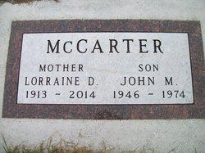
McDonough, Maureen  1999 Cancer | 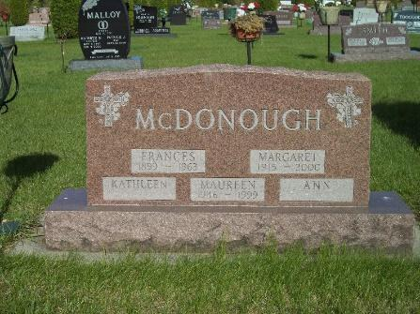
Moylan, Patty Martin  2/15/2015 Lung Cancer  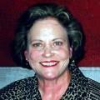 | Moylan, Patricia Ann age 68 of Burnsville passed away Feb. 15, 2015, after a courageous 6-month battle with cancer. Pat will be remembered for her courageous and loving spirit. She was a wife, mother, and grandmother who left an enduring legacy for her family; she will be greatly missed by all who knew and loved her. Pat is survived by her husband, Patrick; children: Jennifer (Jeff) Schwartz, Sara (Mark) Froemke, and Colin (Alyssa) Moylan; grandchildren: Tyler, Caden, Oliver, and Lucy; also by other loving family and many friends.
Moylan, Patrick  1/23/2025  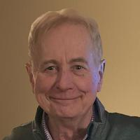 | Moylan, Patrick M. (1945-2025)  Age 79, of Burnsville, passed away peacefully on January 23, 2025, surrounded by his devoted children.  Patrick, known affectionately as "Pat," was born in Winona, MN, on December 15, 1945. He was the son of the late Leo and Mary (Schneider) Moylan and the only child of the family. After the untimely death of his father, Pat was raised by his mother in Rochester, where he attended Catholic grade school and graduated from Lourdes High School in 1963. He cherished his youthful summers spent in Glen Ullin, North Dakota, where he created lifelong memories with cousins and enjoyed countless days of fishing.  After high school, Pat earned his Bachelor of Science degree from St. Mary’s University in Winona and later pursued a Master of Science degree in biology from the University of North Dakota. His passion for education led him to Washington University in St. Louis, where he served as an assistant professor. Over time, however, Pat found his true calling in the business side of the healthcare industry, launching a successful 30-year career in healthcare administration. He began his journey at the American Heart Association and was later recruited to Park Nicollet Healthcare System, where he played a key role in its growth and development. As Vice President of Park Nicollet, Pat was widely respected for his leadership, particularly his commitment to empowering women in highly regarded doctoral and attending roles. He also played an instrumental role in the merger of Methodist Hospital and Park Nicollet.  Above all, Pat was devoted to his beloved wife, Patty. Together, they spent over 40 years raising their children, traveling, and enjoying the company of treasured friends, including the Gravatt and Balint families. In their retirement, they were blessed with 13 wonderful years in Naples, FL, where they were frequently visited by their children, grandchildren, and friends.  Pat’s memory will be cherished by his loving children: Jennifer (Jeff) Schwartz, Sara (Mark) Froemke, and Colin (Alyssa) Moylan, as well as his grandchildren: Tyler, Caden, Oliver, Lucy, Adaline, Seamus, and Matilda.  A visitation will be held from 10:00-11:00 am on Thursday, January 30, 2025, with a ceremony to follow at White Funeral Home, 12804 Nicollet Ave, Burnsville. In lieu of flowers, the family requests that donations be made to the American Heart Association.
Mumford, Kathy Tepoel  12/23/2023  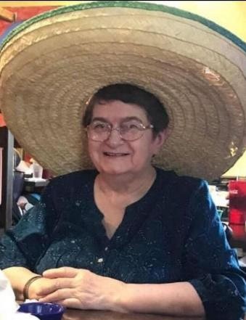 | Beloved mother, grandmother, great-grandmother, sister, and aunt Kathleen Mumford entered into rest on Monday, December 4, 2023 at her home in Branson.  Kathleen was born on October 29, 1945 in Superior, Wisconsin. She was the daughter of Ray & Elsie Tepoel. Her family moved to Minnesota when she was a young girl and she resided in Rochester. She graduated from Lourdes High School. Kathleen was the proud mom to four children. Along with caring for her family, she worked hard in the hotel and restaurant industry. Kathleen moved to Branson with her daughter Andrea and family in 1998. In Branson, she was a dedicated employee for many years with Myer Hotels.  Above all things, Kathleen loved her family. Her greatest joy was being a grandma and spending time with her children and grandchildren.  Kathleen was preceded in death by her parents; her son, Marcus Mumford; brothers, Ronnie & Russell; and sisters, Betty & Judy.  Her presence will be deeply missed by her daughters, Andrea Topka of Branson, Shannon Bowers of Nephi, UT and Robyn Mumford of La Crosse, WI; her nine grandchildren; her great-grandchildren; two brothers, ten sisters and several nieces and nephews.  Memorial services will be Sunday, January 21, 2023 in Snapp-Bearden Funeral Home & Crematory, Branson. She will be laid to rest with her family in St. Margaret Cemetery, Byron, MN.
Nardinger, Vicky Miller  1/21/2024  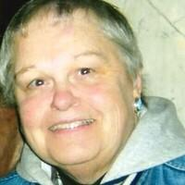 | Vicki Joan Nardinger, 77, of Lake City, passed away on Sunday, January 21, 2024, at Mayo Clinic Hospital-Rochester, Saint Marys Campus with her family by her side. She was born on August 14, 1946, in Rochester to Paul and Delores (Cunningham) Miller. Vicki grew up in Rochester attending St. Francis School and graduating from Lourdes High School in 1964. On January 9, 1971, she married the love of her life Clement Nardinger at St. Pius Catholic Church in Rochester.  After marriage the Nardinger’s lived in the Lake City area. Vicki was employed in the bakery department of Fiesta Foods in Lake City for many years, and worked at the Lake City School Cafeteria, and Kwik Trip.  Vicki greatest joy was spending time with her family, and she never missed her grandkids sporting events. She also enjoyed going camping and visiting Treasure Island with her husband Clem, liked going shopping, loved Wong’s Egg Rolls, and loved watching the Minnesota Vikings.  Vicki is survived by her loving husband of 53 years, Clement Nardinger of Lake City; three daughters, Jody Breuer of Lake City, Jill (Dennis) Carrell of Red Wing, and Amy (Jeff) Daggett of Lake City; five grandchildren, Colten, Logan, Emily, Laura, and Delaney; three brothers, Mike (Linda) Miller of Mankato, Bernie (Jan) Miller of Huntley, IL, and Todd (Lisa) Miller of Rochester. She was preceded in death by her parents, a grandson, Owen, and a brother, Tom.  A memorial service will be held at 2:00 p.m. on Saturday, January 27, at Schleicher Funeral Homes, Lake City Chapel, with Father Thé Hoang officiating. Friends and family may visit from 12 noon until the time of service at the funeral home on Saturday.
O’Neil, John  Heart Attack | The funeral Mass for John M. O’Neil was held at Ascension Catholic Church in Chesterfield, MO. There was a private burial. Mr. O’Neil, 52, died of a heart attack on April 23rd, 1999, in Chesterfield. He was born May 9, 1946, in Kasson. He graduated from Lourdes High School in Rochester and Iowa State University. He served in the Navy and later resided in St. Louis. Survivors include one son, Michael, and one daughter, Elizabeth, both of Chesterfield, his step-mother Rosanna O’Neil of Rochester; three sisters: Pauline Brodek of Racine WI, Patricia Kolb of Faribault, and Sharon Remmen of Wickenberg, AZ, and special friend Connie O’Neil. His father and mother preceded him in death.
Pierce, Joan Frisvold  2021 Stroke complications  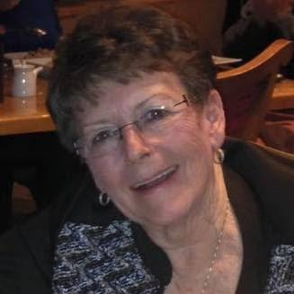 | The following was posted on Facebook by Joan’s daughter, Erin Hoock.  My mom, Joan Pierce, passed away yesterday while sleeping. She had recently undergone a triple bypass and had complications, including a stroke. She worked really hard at rehab and managed to make it home. I talked to her yesterday morning. She was excited to go on a grocery shopping trip with Dylan Hoock so she laid down to take a nap. That was the last time we talked. I keep thinking if I needed to say more during our last conversation but really, it was perfect. She was being positive, she joked with me and we laughed. Love you always Mom. Enjoy hanging out with Kate. See you on the other side.
Reisdorf, Sandy
1/9/2008 Cancer
Rossman, Dave  10/3/2012 Brain Cancer  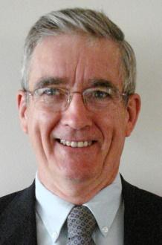 | David Michael Rossman, age 65, of Rochester, died Wednesday, Oct. 3, 2012, at home surrounded by his family. He was born Oct. 8, 1946, in Rochester, to Mark and Florence Rossman who farmed near Douglas. David and Kristine Marie Berlin were married in St. Bartholomew Catholic Church in Wayzata, on May 23, 1970. David graduated from Lourdes High School and Rochester Junior College with an Associate of Arts degree. He continued his education at the University of Minnesota graduating with high honors with a Bachelor of Civil Engineering. He earned his professional license while employed by the City of St. Paul. David moved to Rochester in 1974, becoming the design engineer for the Public Works Department. He served the city as transportation engineer from 1978 until his retirement in 2001.  He is survived his wife, Kristine; and two daughters, Catherine (Chad) McDonald and their children Connor and Liam of Hudson, Wis.; and Sarah (Ryan) Gilgenbach and their children, Sophia, Aidan, and Nia of Mound. David is also survived by his sister, Mary (Chuck) Nagy of Schaumberg, Ill.; brother, James (Brenda) Rossman of Douglas; and sister, Florence of Rochester. He was preceded in death by his son, Benjamin who died Oct. 11, 1977, of aplastic anemia and his parents. Burial will be in Calvary Cemetery.
Sehl, Ed  9/25/24 Heart Failure  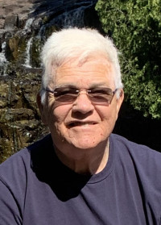 | Matthias Eduard “Ed” Sehl II, age 78 of Rochester, passed away at his home on Wednesday evening September 25, 2024.  Ed was born on January 17, 1946 at St. Marys Hospital Rochester to Francis and Beatrice (Keily) Sehl. He was the oldest of 15 children. He graduated from Lourdes High School in 1964. He attended Washington University in St. Louis, MO, Rochester Community College, and the University of Minnesota, receiving a BA degree in History. On August 30, 1969, he married Jerelyn “Jeri” Ryan in Davenport, IA. They lived in Minneapolis briefly before moving to Rochester in August of 1970 where they lived for the past 54 years. Ed worked for the Nicotine Dependence Center at Mayo Clinic for over 20 years. He retired during the Covid epidemic. He loved hunting pheasants with his dogs, the Saint Louis Cardinals, the Minnesota Vikings, and the Rochester Public Library.  Ed is survived by his wife Jeri of Rochester, and his son Joseph of Apple Valley, MN.  He is preceded in death by his parents Bea and Francis, sisters Barb and Deb, brother John, infant brother Anthony and an infant son, Matthias Eduard III.  The Funeral Service for Ed will be held at 11:00AM on Saturday, October 12, 2024 in the River Park Chapel at Macken Funeral Home. Visitation will be held one hour prior to the service in the chapel. A luncheon is planned to follow. Memorials are preferred to Clean Water Action or Lourdes High School.
Sheehan, Marie
11/4/2018
Smith, Dave
11/29/2014 Heart Attack
Spaniol, Rick  1/23/2005  Non-Hodgkin’s Lymphoma  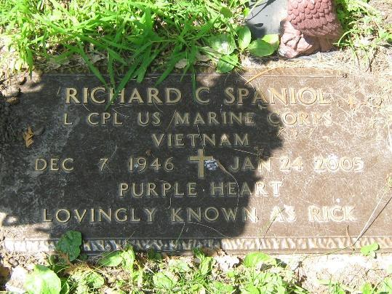 | Mr. Spaniol, 58, of Rochester, died Monday (Jan. 24, 2005) of non-Hodgkin’s lymphoma, at his home. He had been ill for 8 1/2 years. He was born Dec. 7, 1946, in St. Cloud, Minn. He grew up in St. Paul, and in 1958, moved to Rochester. In 1964, he graduated from Lourdes High School in Rochester. He received an associate in arts' degree in accounting from Rochester Community College and a technical degree in auto mechanics from Rochester Vocational School. He served in the Marine Corps from 1967 to 1969. From 1967 to 1968, he fought in Vietnam, earning three Purple Hearts and other combat medals. On Jan. 8, 1972, he married Katherine Johnson in Rochester. Mrs. Johnson is a PMR at Saint Mary’s Hospital. Mr. Spaniol worked at the Rochester Post Office from 1974 until his retirement in 2001 due to ill health. He was a member of Bethel Lutheran Church, Rochester VFW, American Legion, Disabled American Veterans, Minnesota Street Rod Association, and Good Guys and Zephyrs Old-time Car Clubs. He collected guns and model cars, and enjoyed old cars, old-time movies and Minnesota sports. Survivors include his wife; one daughter, Nissa (Philip) Kraling of Rochester; two sons, Zachary (Dawn) of Albertville, Minn., and Joshua (Heather) of Rochester; four grandchildren; his parents, Babe and Dick Spaniol of Rochester; one sister, Toni (Toby) Deters of Rochester; and one brother, Philip (Cathy) of Katy, Texas. His maternal and paternal grandparents preceded him in death. Friends may call from 4 p.m. to 8 p.m. Wednesday at Macken Funeral Home in Rochester, and an hour before the service Thursday at the church. Memorials are suggested to Bethel Lutheran Church or Seasons Hospice.
Sheehan, Marie
2018
Stevens, Mike  5/20/2009 Lung Cancer  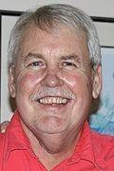 | Mr. Stevens, 62, of Rochester, died Wednesday (May 20, 2009). Michael Harold Stevens was born Sept. 6, 1946, in Rochester. He attended Lourdes High School, then John Marshall High School, graduating in 1964. He then went to the University of Minnesota and graduated with a degree in aeronautical engineering. From 1968 to 1971, he worked for Honeywell in its Ordinance and Aerospace Division. He also attended night school at the University of Minnesota and received an M.B.A. He was married to Maureen Rosener and later divorced. Mr. Stevens went to work for a consulting firm and sold insurance from 1971 to 1975, then bought Fitting Insurance Co. from his father, Harold. He retired in 2006. A lifelong member of St. John's Catholic Church, he served on the finance committee for 10 years and the Parish Council for three years. He is survived by two daughters, Jennifer Mary Stevens (Sean Brakeman) and Sara Catherine Stevens both of Chicago; two sisters, Sharron Bernhagen of Richfield, Minn., and Susan (James) Hausman of Rochester; a brother, Nicholas (Rosemary) of Burnsville, Minn.; and 14 nieces and nephews. He was preceded in death by his parents, Harold and Trudis Stevens.
Stevens, Maureen Rosener  7//2020 Brain Cancer  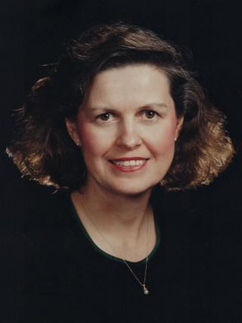 | Maureen Ann Stevens (Rosener) aged 74, passed away peacefully in Chicago, IL on July 9, 2020 with her daughters Jennifer and Sara at her side. She journeyed with grace, courage and acceptance, never once complaining as her health declined due to brain cancer which she was diagnosed with in August of 2018.  Maureen is survived by her daughters Sara Stevens, Jennifer Stevens Brakeman (Sean Brakeman), her two grandchildren Michael and Samantha Brakeman who reside in Chicago, Illinois, her brother Richard Rosener (Joanne) of Rochester, Minnesota, her beloved nieces and nephews on the Rosener and Stevens sides of the family and her many dear friends and co-workers from the Mayo Clinic and Waters on Mayowood communities. She was preceded in death by her parents Mary and Theodore Rosener and her identical twin sister Marilyn Berens (Rosener).  Maureen was born on February 25, 1946 in St. Paul, MN. She grew up in Rochester, MN and was a member of St. Frances parish and attended grade school there. She graduated from Lourdes high school in 1964 and was married to Michael Stevens in 1967. Maureen had her daughters Jennifer and Sara while living in Minneapolis, Minnesota until 1976 when the family moved back to Rochester. She was also a member of St. Johns Parish where she was active in the Women’s community and grade school.  Maureen worked for Mayo Clinic in the accounting department for 29 years until her retirement in December of 2014. She was recognized by co-workers and friends for her dedication to Mayo Clinic and St. Mary’s. Customer service was an area where Maureen stood out as one of the best and she delivered training within the Mayo community for a number of years on this topic.  Known for her boundless energy, tireless work ethic and wonderful sense of humor, she could not sit still in retirement and found the perfect role of part-time concierge at the Waters on Mayowood. There she assisted the residents and staff of this senior-living community with all the goings-on of daily life. She greeted guests, residents and coworkers with a lively smile and warm and caring presence.  She will be dearly missed by her family, friends, care-givers and co-workers. Her family would like to give a heart-felt thank you to her dear friends Sandie Jones, LuAnn Rueb, Sister Corona Malis and Rosie Lund for their years of love and caring, especially in the last days of her life. Also thank you to her many other friends, neighbors and colleagues and to the physicians, nurses and staff at Mayo Clinic, St. Mary’s and Samaritan Bethany for their care through her illness.
Struif, Judy Miller  4/14/2011 Brain Aneurysm  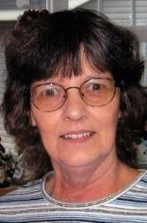 | Judith Ann Miller was born on July 26, 1946, in Rochester to Hugh and Mary Miller. Judy grew up in Rochester and graduated from John Marshall High School. On Feb. 20, 1965, she married Ronald “Ron” Struif in Rochester. Judy started her own commercial cleaning company “Judy’s Cleaning,” which she owned and operated with her husband, Ron. At the time of her death, she worked at Hancock Fabrics in Rochester. Judy was a devout supporter of her family, and enjoyed any activity that involved her husband and their children. She was a wonderful wife and a caring mother. She enjoyed making quilts and hand-made crafts for her family and friends along with reading any and all books. She is survived by her husband, Ron, of 46 years, and her children, Joseph (Cristine) Struif of Stewartville, Marie (Ron) Tointon of Rochester, and Thomas Struif of Colorado Springs, Colo.; four grandchildren, Zachary, Jacob, Tyler and Katelyn; a brother, David (Karen) Miller of Maple Grove, Minn.; and a sister, Diane Ellson of Dodge Center. She is preceded in death by her parents. Burial will be in Calvary Cemetery.
Vasiloff, George  3/9/2015 ALS  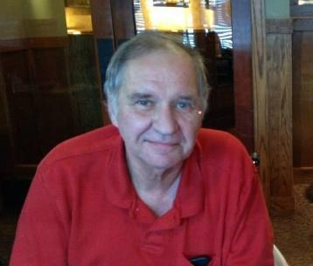 | George Michael Vasiloff, 67, died peacefully Monday, March 9, 2015, at his home. George proudly served his country as a U.S. Marine. An extraordinarily talented musician, his love of music was rivaled only by his love of the Minnesota Vikings, scotch, cigars and his family. George was very proud to create a video for the Ice Bucket Challenge last summer, which went viral, raising awareness and money for ALS research. To continue his efforts, in lieu of flowers, please send donations to Project ALS, a research nonprofit dedicated to finding a treatment and cure for this devastating disease (projectals.org/support-us/donate-now). He is survived by his wife, Jann Vasiloff; his children, Katherine and Michael Vasiloff; his father, George Charles Vasiloff; his three sisters, Gloria Przybocki, Joan Riggert and Barbara Vasiloff; as well as many other loving family members and friends. George will be resting at Quantico National Cemetery, but forever with us in our hearts. Services will be private.
Warren, Barry  12/13/2019 Cancer  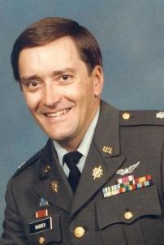 | He was born in Hutchinson, Kan., on Aug. 2, 1946, to the late Ed and Eunice Warren of Rochester, where he resided during his youth. Barry graduated from Lourdes High School, Rochester Community College, University of Arizona, USC, and University of Mainz, Germany. He proudly served his country in the Army for 26 years. Barry is survived by his loving wife of 44 years, Cindy; son, Vaughn; daughter, Kara (Jon); grandson, Jaxon; brothers, Mark (Jasmine), Bob (Kristi) and John (Lory); sisters, Kathy and Wendy (Steve); sisters-in-law, Connie (Lynn) and Cathy (Robert); many nieces and nephews; and numerous friends. Interment will be in Salisbury National Cemetery at a later date.
Welhaven, Jim  8/8/2024  Parkinson’s + Dementia  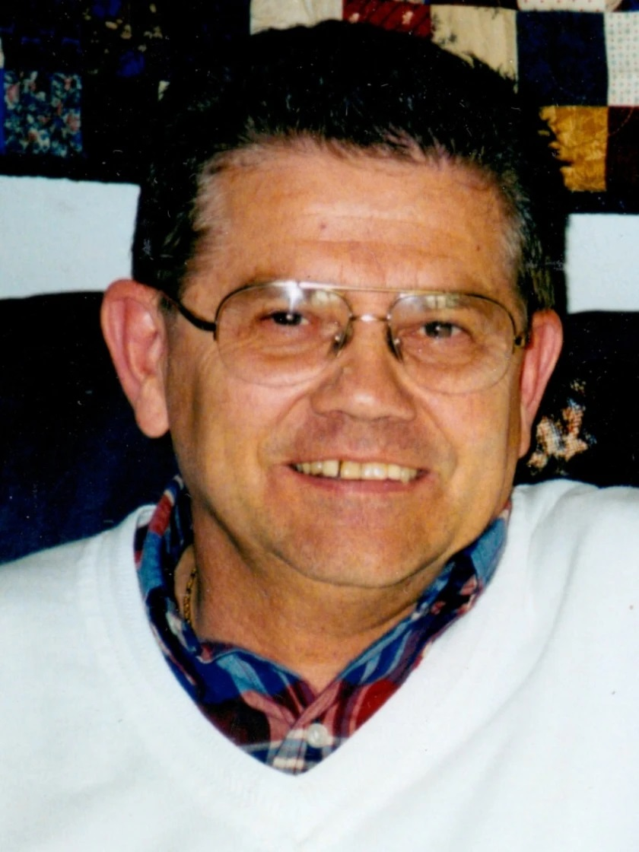 | James “Jim” Earl Welhaven passed away peacefully with his family by his side on August 8, 2024, of complications from Parkinson’s disease with dementia. He was born to Earl and Margaret “Peg” Welhaven in Duluth on January 18, 1946. Six months later, they moved to Rochester where Earl accepted a position at Lourdes High School as their first band director. In 1954, Jim’s parents founded Welhaven Music, and Jim began helping out in the music store in high school. He graduated from Lourdes High School in 1964 and then attended Saint Mary’s College in Winona. In 1966, he joined the U.S. Army Reserves and was honorably discharged in 1972. Then, Jim and his brother John began to run the family business with their brother Tom. In 1985, he married Rita and they had two children, Cole and Emily. Jim was an avid sports fan who never missed a game, match, or meet that his children participated in and watched nearly every Minnesota Twins and Minnesota Vikings game. He also enjoyed spending quality time with his two grandchildren Michelle and George.  He was preceded in death by his parents Earl and Peg Welhaven, in laws Harry and Phyllis Theiss, niece Margaret “Mimi” Roberts, great nephew Jake Roberts, great niece Makenzie Roberts, and nephew Ryan Lange. He is survived by his wife Rita, son Cole (Danielle) Welhaven, daughter Emily Welhaven, and grandchildren Michelle and George Welhaven. He is also survived by his siblings Mary (Patrick) Sullivan, John (Mary) Welhaven, and Tom (Vicki) Welhaven; sister-in-laws Charlotte (Craig) Hansen and Judy (Dan) Lange; and many nieces and nephews.  The family wishes to thank the wonderful staff of Mayo Hospice for their amazing care over the past year and a half.  A Mass of Christian burial will take place at 10:30 am, Wednesday, August 14, 2024, at the Co-Cathedral of St. John the Evangelist (11 4th Ave SW Rochester, MN). Visitation will take place on Tuesday, August 13, 2024, from 5:00 PM - 8:00 PM in the River Park Chapel at Macken Funeral Home (1105 12th St. SE Rochester, MN) and one hour prior to the service at church on Wednesday.  In lieu of flowers, the family suggests memorials to the Lourdes High School Music Endowment Fund.
Yochum, Paul  12/3/2016 Cancer | Paul E. Yochum 70, of Mesa, Arizona passed away on December 3, 2016. Paul was born on August 30, 1946, in Ottumwa, Iowa. Paul is survived by his mother and dad Bob and Martha Yochum. Paul is also survived by two brothers Bob from Austin, Minnesota and Mike from Rochester, MN. Paul is preceded in death by his sister Patricia from Rochester, MN. Paul graduated from Saint Mary's University in Winona, MN. Paul also served in the Air Force. After leaving the Air Force Paul pursued his career as executive chef, and regional manager of hotels.  and restaurant chains. For the last 30 plus years he has been a caregiver to his parents.

